**NETWORK RECONNAISSANCE & DISCOVERY**

**NSLOOKUP**

* Installing nslookup package

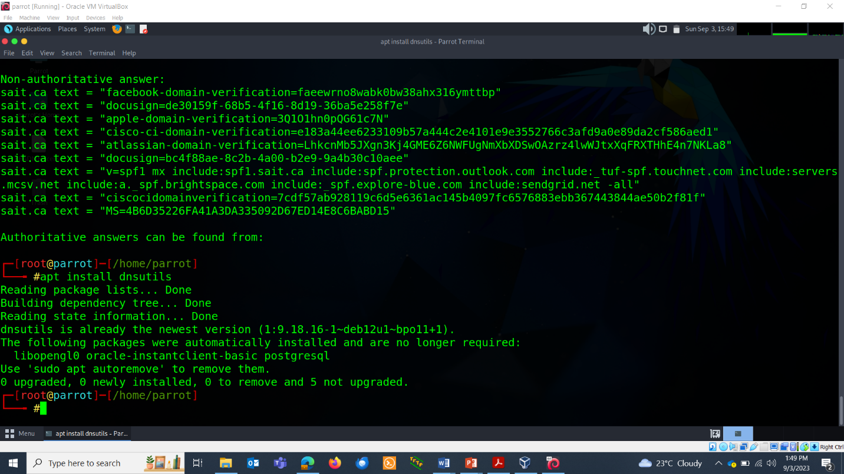

* Basic nslookup command:

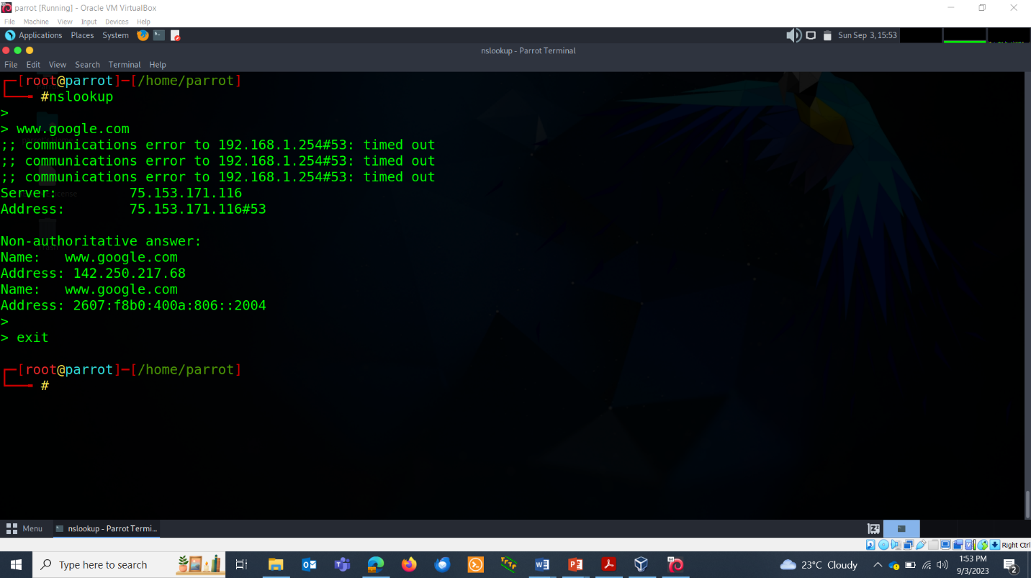

* The above mode is called interactive mode. Command exit to come out of it.
* Non-interactive mode:

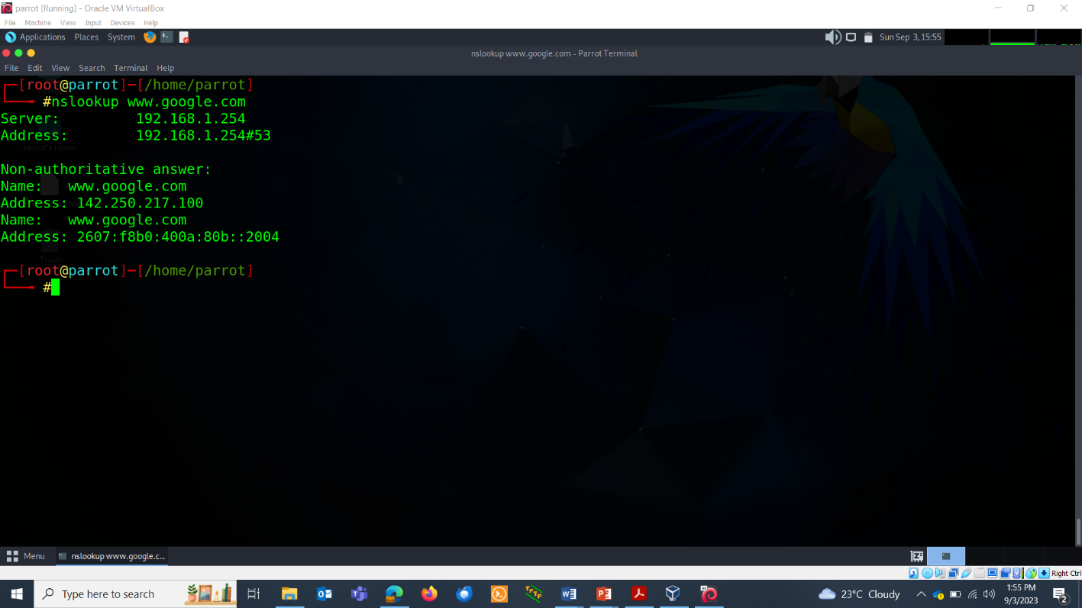

* Nslookup type options: As you know dns has different types, which are A, AAAA, NS, TXT.
* NS type: Name server(NS) record stores names of the domain name server.

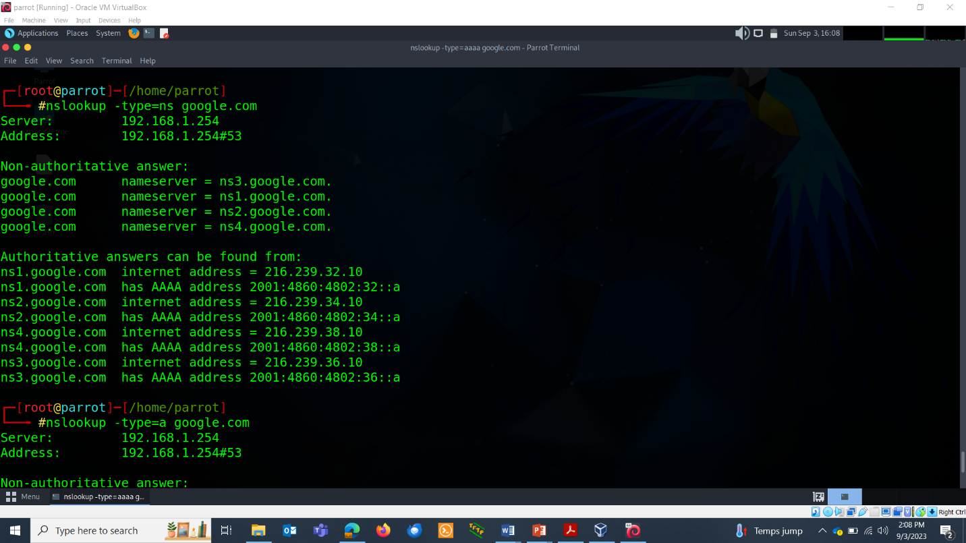

* A & AAAA record: A record stores ipv4 address and AAAA record ipv6 address.

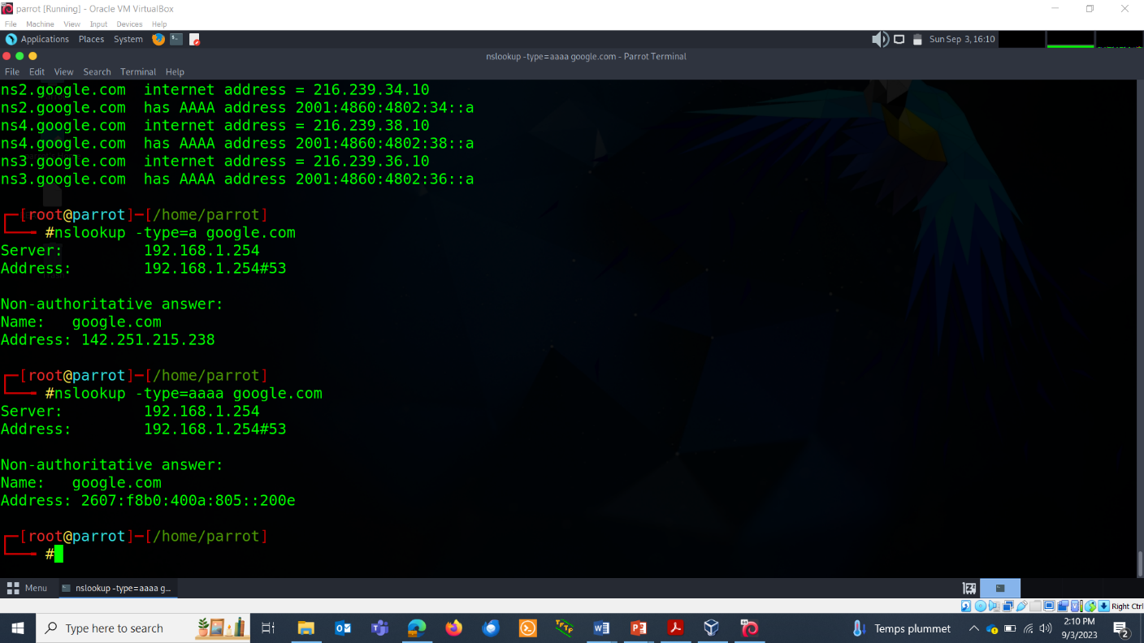

* MX record: They store all relevant mail exchange server data.

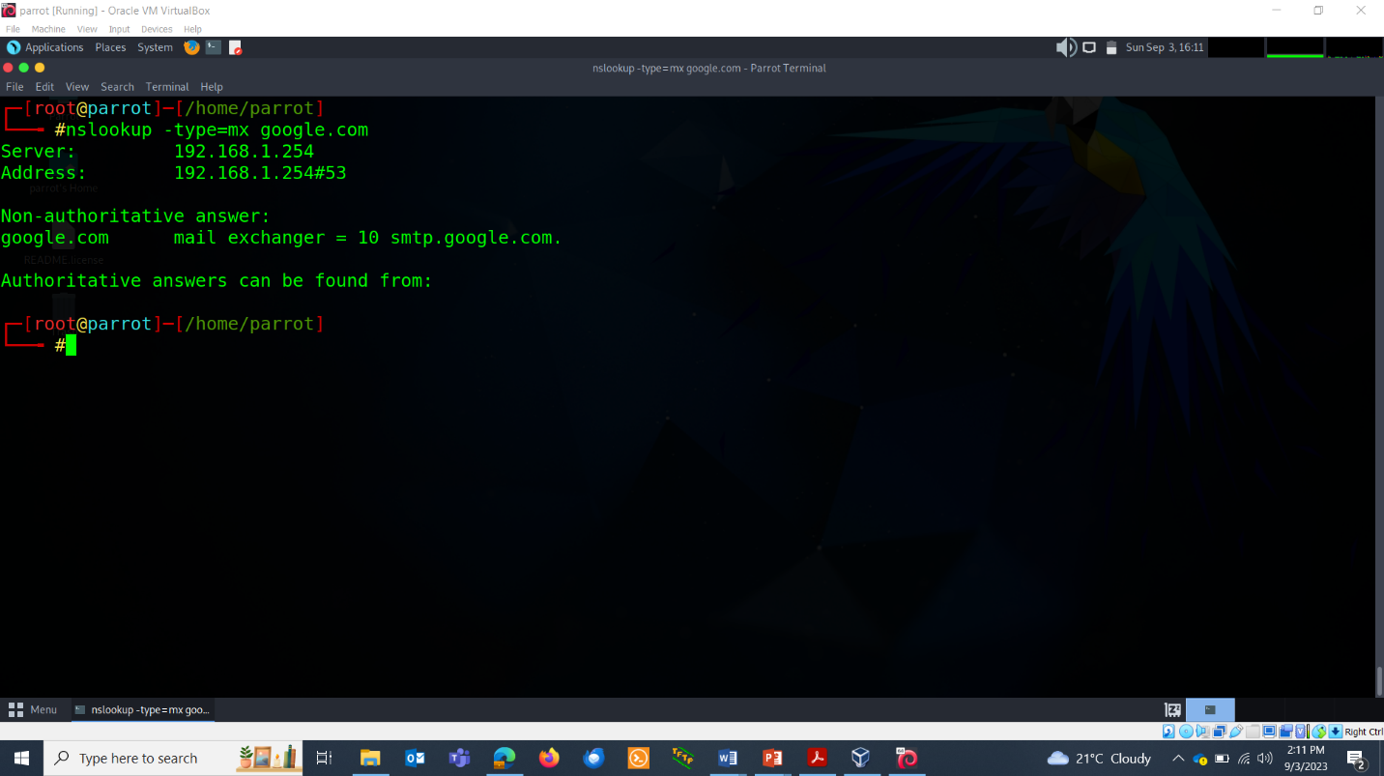

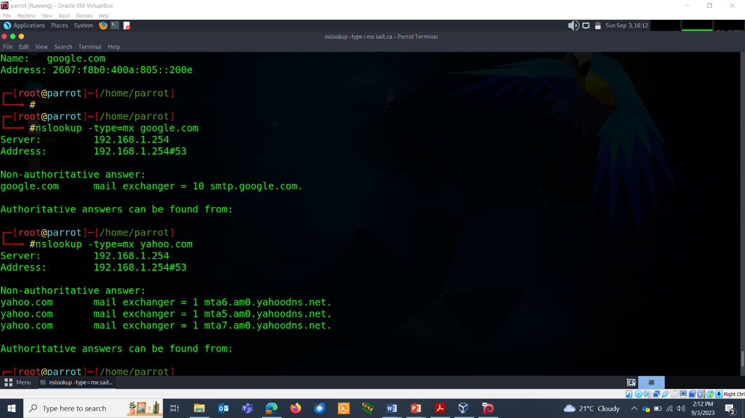

* Reverse DNS lookup:

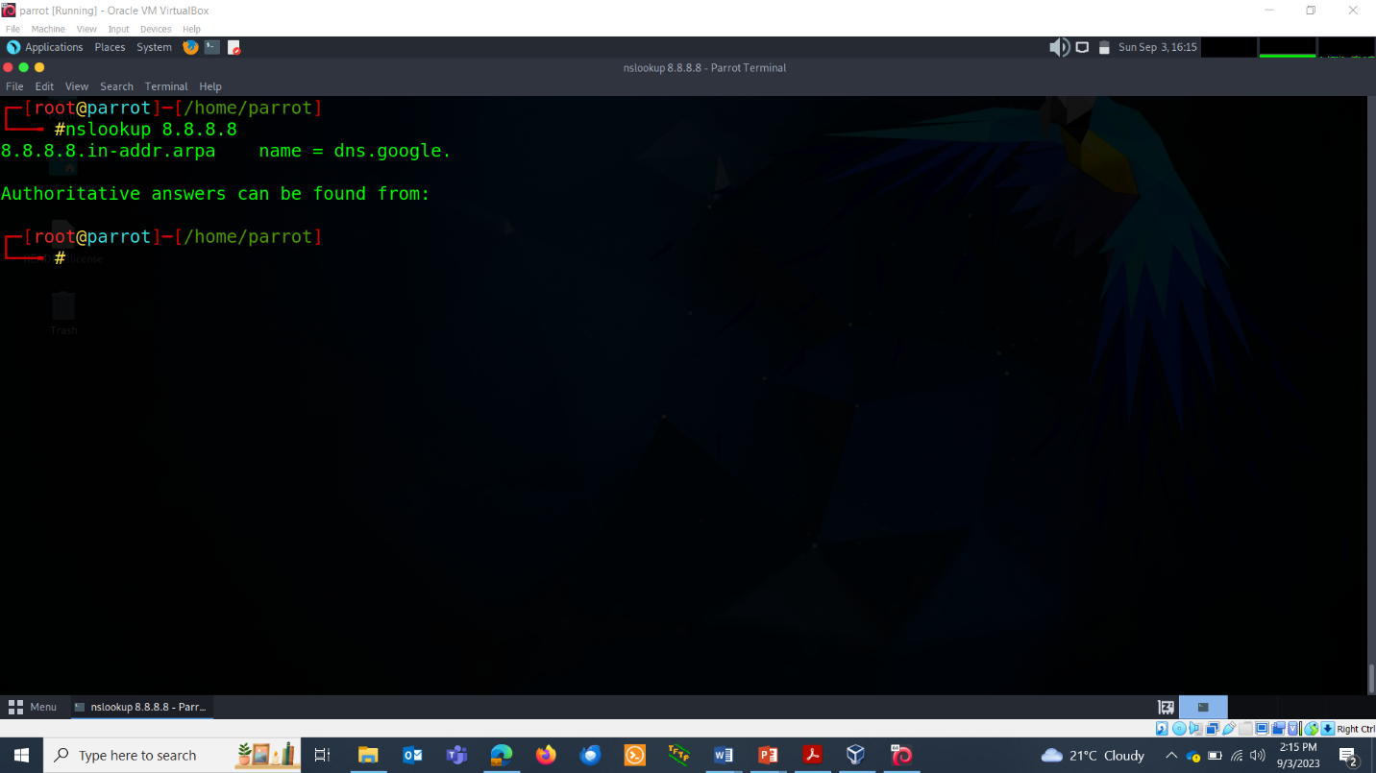

* State of authority record: It provides authoritative information about the domain and the server, such as the email address of the administrator, serial number, refresh interval, query expiration, time etc.

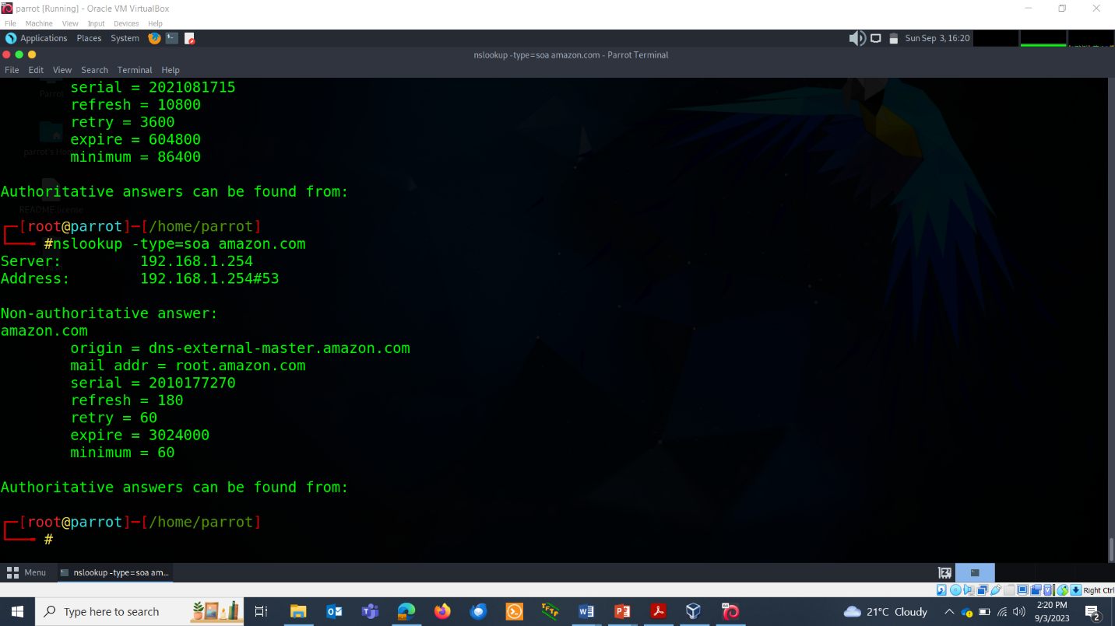

**PING PACKET FRAGMENTATION**

The -f switch with the ping command is used to set the "Don't Fragment" flag in the IP header of the ping packets. When the "Don't Fragment" flag is set, it indicates to routers along the path that the ICMP echo request packet (ping packet) should not be fragmented into smaller packets if it encounters a network with a smaller Maximum Transmission Unit (MTU).

In practical terms, when you use the -f switch with ping, you are telling the network to attempt to send the ping packet with a size that does not exceed the MTU of the network. If the ping packet's size exceeds the MTU of any intermediate network device, such as a router, it will be dropped, and you'll receive an "ICMP Destination Unreachable - Fragmentation Needed" error message.

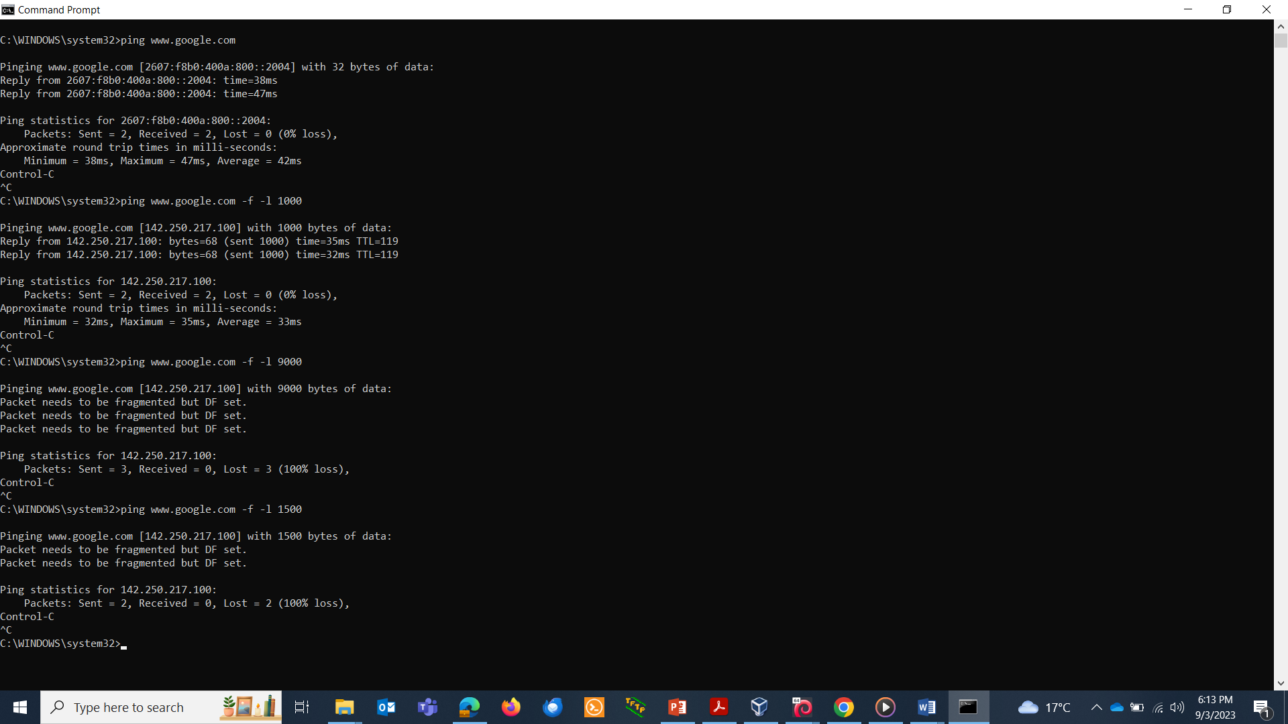

WHOIS

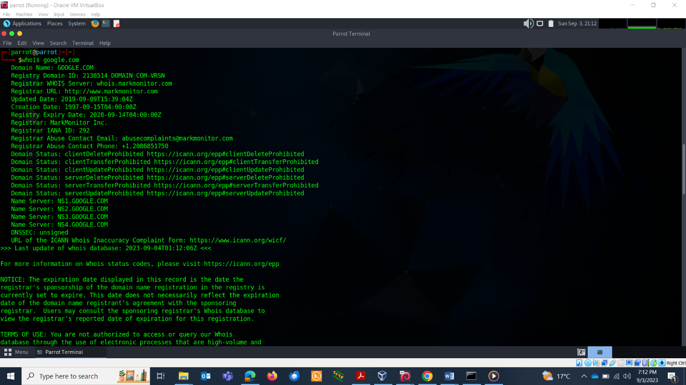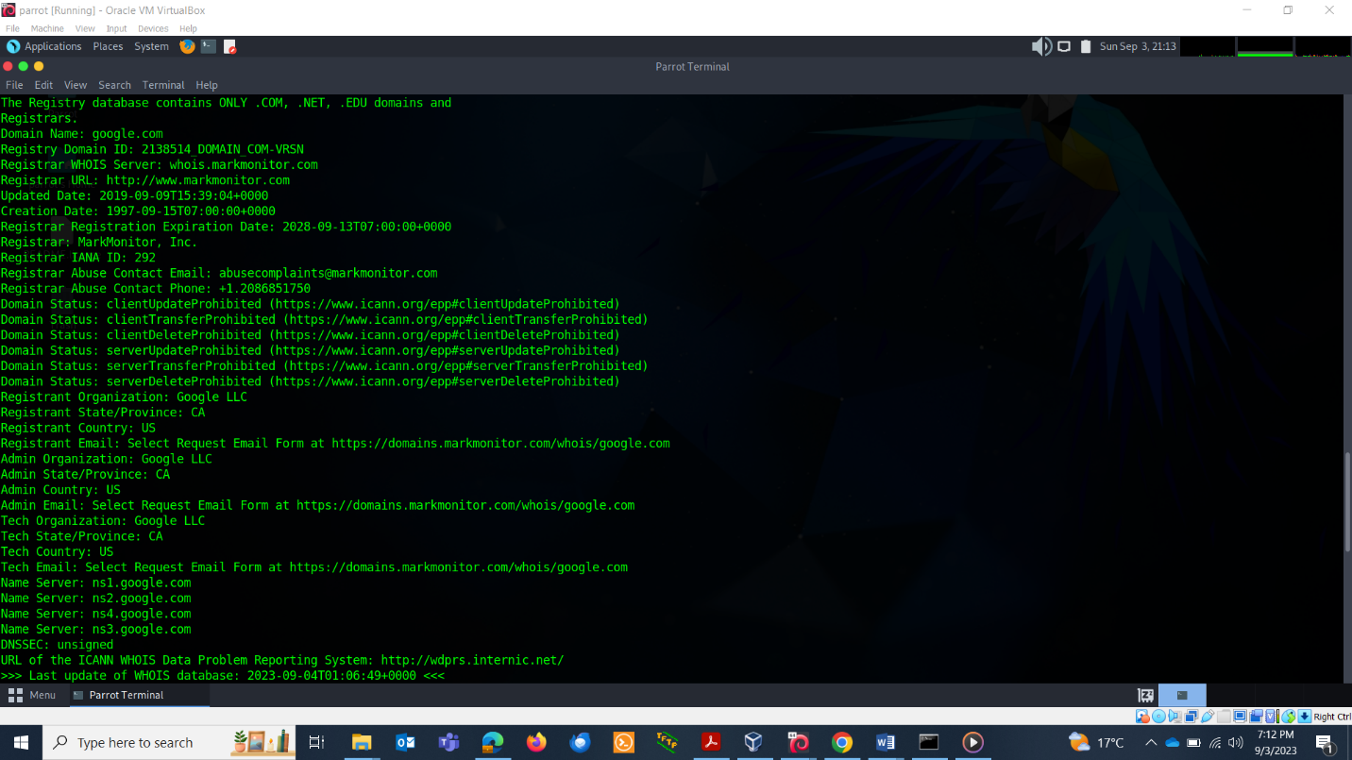

**theHarvester tool**

**TASK**

* It is a passive tool that comes with kali linux used to harvest the email addresses of an organization.
* Install it by : pip3 install theHarvester.
* 